

COVER SHEET

Student Name: | Abdurahmanov Abdulla | Module Name: | Development of Mobile Applications
Student ID: | TM223-0927 | Module Code: | COS211
Assessment Type: | Individual | Learning Outcomes Assessed:
Deadline: | 6.05.2026 | Date of Submission: | 3.05.2026
Institution: | TMC Institute in Tashkent

Signature of Assessor: | Signature of Moderator: |  | Overall, Mark (subject to ratification by exam board)
This work is fully done by me and I referenced all the sources I used in this work.
Student signature: |  | Abdurahmanov Abdulla Ravshanovich

Table of contents

Introduction 3
Objectives 3
Structure 3
Architecture Design 4
Main.dart 5
Navigation 5
Home Screen 5
Calendar Screen 6
Stats Screen 7
Currency 8
API 8
Add Expense button 9
Expense class & Hive 10
Expense.g.dart 11
App Logic 12
Challenges 13
AI Acknowledgement 14
Conclusion 14

Introduction
This project has been done by Abdulla Abdurahmanov ITD 306 on Development of Mobile Applications. The project presents an Expense Tracker app for keeping track of daily expenses of an individual. The project follows the requirements of the assignment and includes 4+ screens with named routes and with a proper state management. It also includes integration of API, local storage using Hive, Form Validation, a clean UI, as well as Error Handling.

Objectives
The objectives of this assignment is to demonstrate proper understanding of all the topics covered in the module during the semester. It is also aimed to demonstrate proper understanding and implementation of the theory provided by the course leader.

Structure
The project starts with main.dart, which is the file that launches the app and directs the user to the main page. This file is then followed by a number of folders:
- Screens:
In this folder are files dedicated for separate screens of the app. These files include a page for home screen, an expense-adding screen, a calendar, day details screen, as well as a statistic screen.
- Services:
This folder includes files an API service and a hive service.
- Models:
This includes files used for defining what an expense is with necessary fields.
- Providers:
This folder includes expense_provider.dart, where the logic of the whole app is stored.
- Routes:
This folder includes app_routes.dart. This file is needed for correct navigation through the app.

Architecture Design
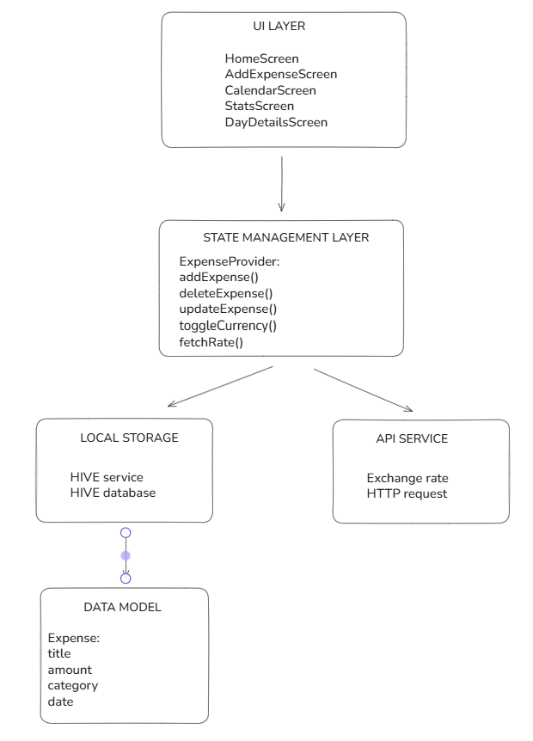

Main.dart
Main.dart file starts with the main function being marked as async because asynchronous operations are performed before the app starts, which is followed by the main function calling WidgetsFlutterBinding.ensureInitialized() method. Following that, Hive is set up for local storage, which opens a box called for expenses to store data. After that runApp is executed to launch the app.

Navigation
While using Navigation.push() and Navigation.pop() with specifying screen names is okay by itself, using routing alongside it makes navigation a lot easier. In this project, app_routes.dart file is responsible for routing. After linking screens with it in the beginning, an AppRoutes class is created where the routes are specified. For home screen the route is “/”; for AddExpenseScreen - “/add”, while for Stats Screen - “/stats”.
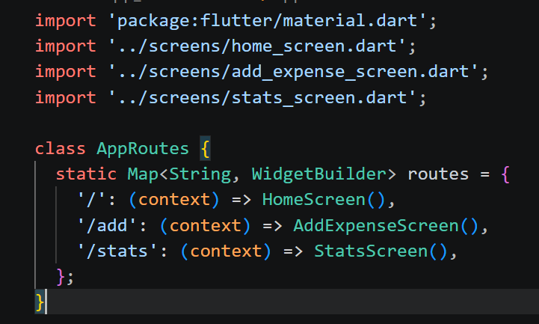

Home Screen
The first page the user is going to see is the home screen with the top of the screen being occupied by three buttons, with first of them being the calendar, the second being the statistics and the third being currency converter. Under the buttons is a container with current balance of the user, which can be displayed in US dollars or in Uzbek sums. This is then followed by a large section for displaying recent transactions, with an add expense button at the very bottom. With a swipe to the right, transactions can be deleted easily.
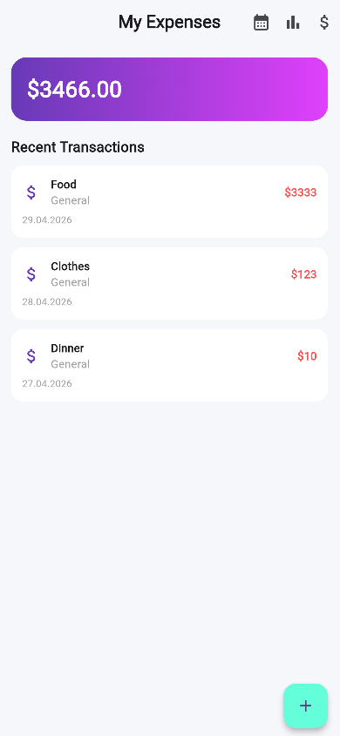
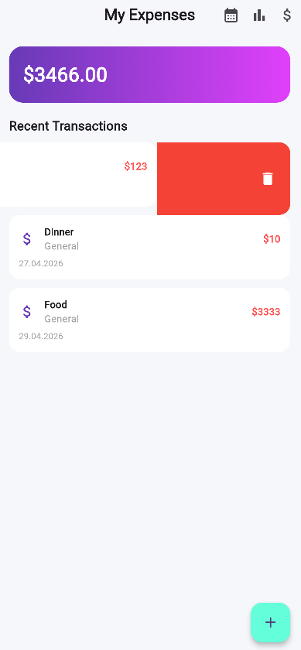
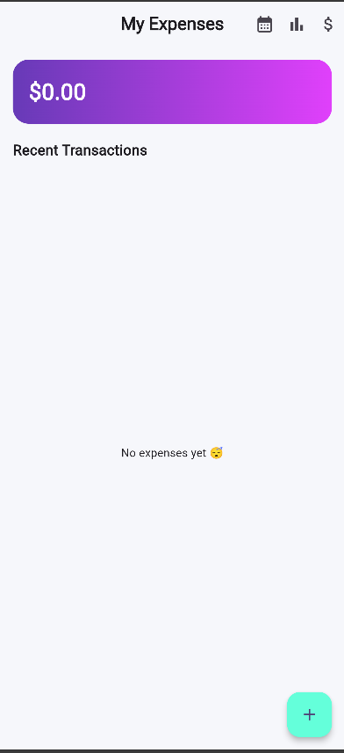

Calendar Screen
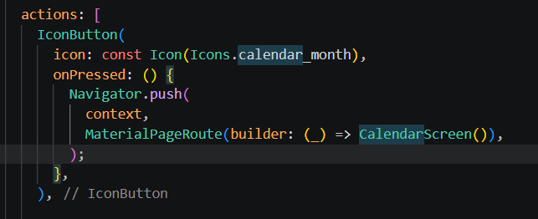
Pressing the calendar button redirects the user to Calendar screen, which is done by Navigator.push() method, as shown in the screenshot below.

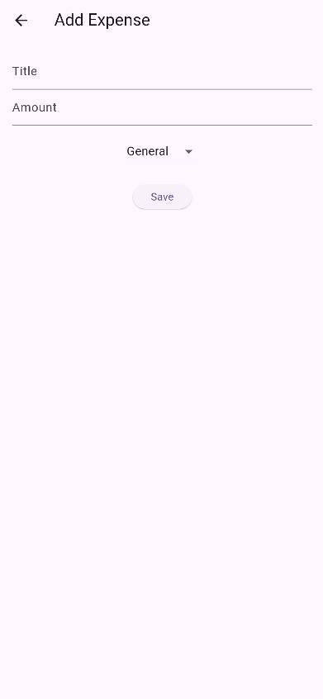
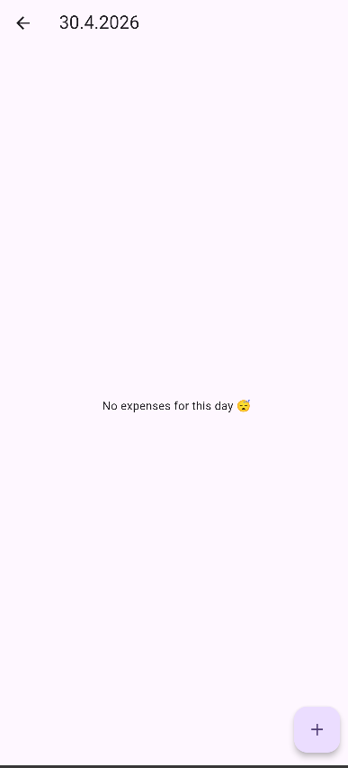
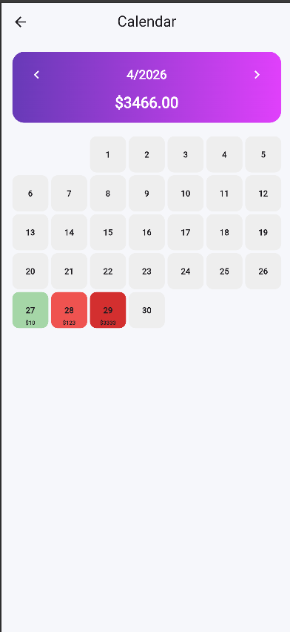
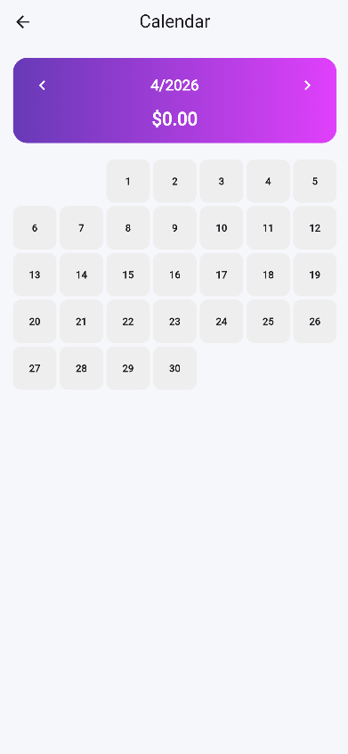
The calendar screen starts with a back button on the top left corner and a title at the center top of the screen, with a container similar to the one in the home screen showing the current date and balance. It also comes with two arrows on the sides which are designed to move through other months. Below is a grid of days of the month, which change their color according the amount of money spent on a particular day. If any day in the grid is pressed, it opens another screen showing all the transactions done that day with a chance of adding another transaction to the list if forgotten.

Stats Screen
Pressing the statistic button redirects the user to the Statistic screen. Just like the previous screen, it has a back button, a title and a currency converter button at the top, with a container showing the total amount of money spent with an overview section below it showing the total number of transactions made, an average amount of money spent a day and what categories the money was spent on.
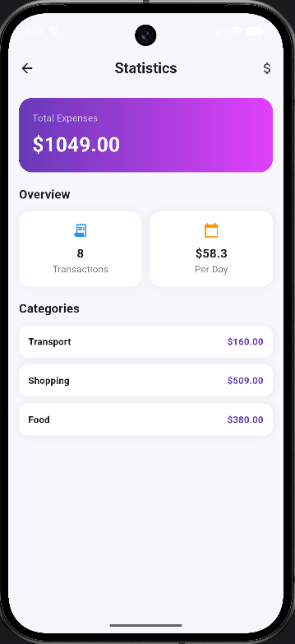

Currency
This section describes how the currency converter button in the home screen and the statistics screen works.
The IconButton checks whether the value of provider.isUzs is true or not. If it is true, the currency converting icon is displayed, if not – it shows a dollar sign. When the user presses on it, toggleCurrency() method is called.
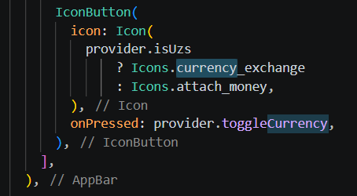
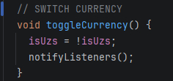

API
This section will show how the API service works. The first thing that is done is getting the current exchange rate of the currencies. This is done by fetchRate() method, inside which an http request is sent with the URL shown in the screenshot. When the response in JSON format is received, it is then converted into Dart object using jsonDecode where UZS rate is taken from. If the process is successful, the UI is updated, but if not the default rate of 12500 is used.
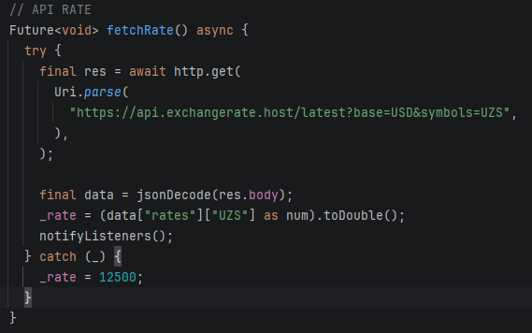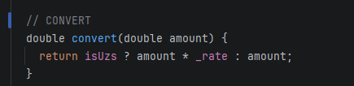

Add Expense button
This section describes how the add expense button works in the home screen. When pressed, it calls Navigator.pushNamed(context, ‘/add’) method. This redirects the user to the screen registered under ‘/add’ route in the app_routes.dart file.
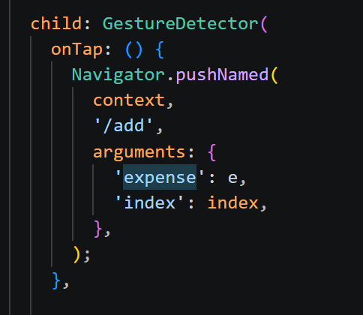
The screen comes with a back button at the top left corner with a title at the top center of the screen. Below it there is a section which asks the user to specify the what the money was spent on, then the amount. Under these fields, there is a drop-down button with categories, such as General, Food, Transport, Shopping, and Bills, with a save button below it.

Expense class & Hive
This section describes how the add expense button works under the hood. To make it work, two files were created: expense.dart and hive_service.dart. While the former file acts as a blueprint to define what an “expense” is, the latter file is used to store them.
In expense.dart, a class called Expense is created with fields such as: title, amount, category and date, with a constructor at the bottom.
In hive_service.dart, a class called HiveService is created. Following that, a reference to the Hive box is created called “expenses”, which is where all the objects of Expense class is stored. Then comes getExpenses() method, which reads all expenses and addExpense() method, which stores objects of Expense class inside the reference of the Hive box.
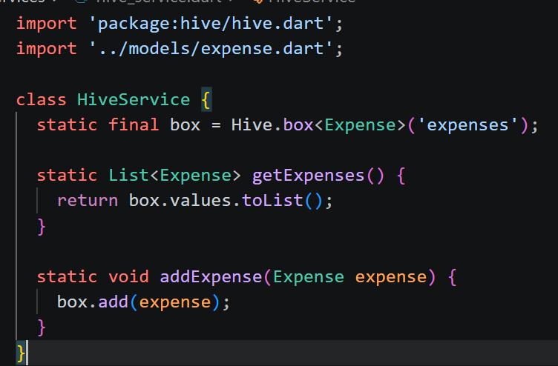
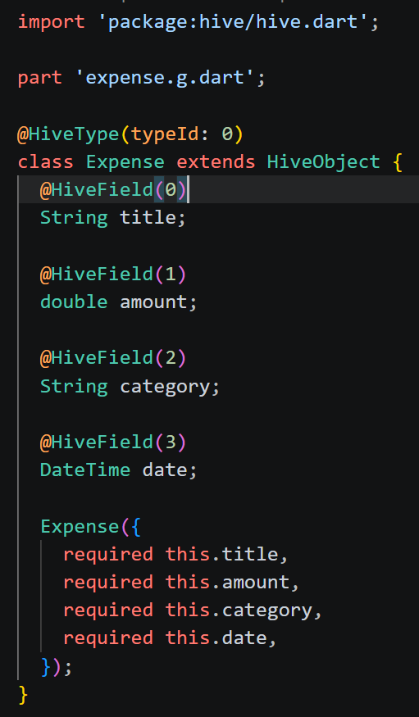

Expense.g.dart
An important detail when it comes to storing objects. There is one more file classed expense.g.dart. This file is automatically created after defining models for Expense class and flutter pub run build_runner build is run.
This file contains ExpenseAdapter class which converts the objects of Expense class into a format compatible with Hive to store them.
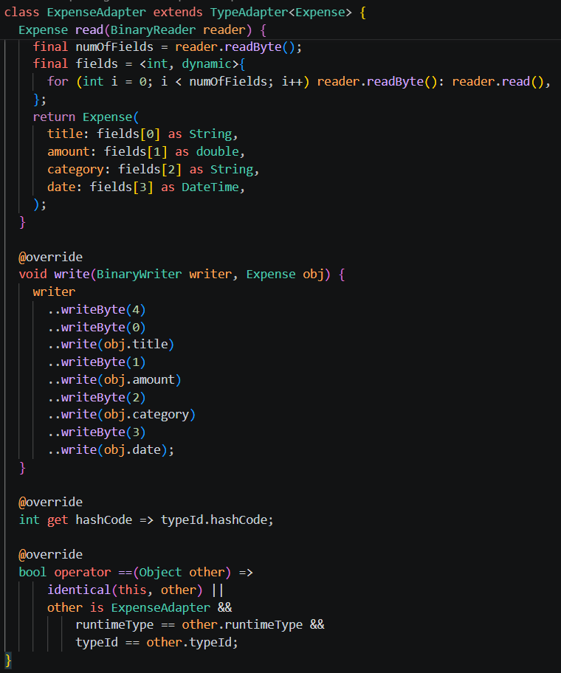
The write method converts the fields of an object into binary code, while the read method does the opposite to view them.

App Logic
This part explains how logic of the entire projects is handled. A file called expense_provider.dart was created. This file is used for state management and it connects the user interface with the data layer.
At the beginning, a Hive box is initialized to store objects of the Expense class into the _expenses list with a loadExpenses() method coming after it to gets data from Hive and updates the UI via NotifyListeners() method
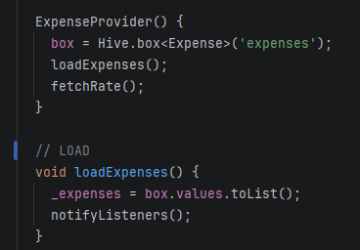
After the code snippets for API service and changing currency come code snippets for: adding, deleting, updating and loading data from the Hive. As shown in the screenshot, the addExpense() method takes an object of Expense class and stores it in the Hive using boxAdd() method and then loads the data with loadExpenses() method.
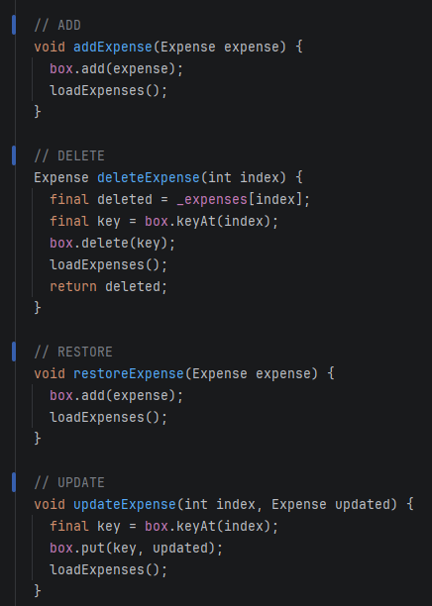
deleteExpense() method works in a way that it deletes an object based on its index. It first gets the object’s key from the Hive using box.keyAt(index) method, then deletes it using box.delete(key) after which it loads the data with loadExpenses() method. At the end, it is returned in case it needs to be restored.
restoreExpense() method uses the deleted object that was returned in the deleteExpense() method, then it adds the object back to the Hive using box.add(expense) and loading it using loadExpenses().
updateExpense() method works in a similar way as deleteExpense() method. It finds the object by its index, then using box.put(key, updated) method updates the object then loads the data with loadExpenses() method.

Challenges
Creating this project was not without challenges.
Initially, when a user launched the app and added expenses with other minor details, all data was lost the next time they launched the app. To resolve this problem, a means for local storage was used – Hive.
Another problem during development was that currency indicator was different on screens. This means that while currency was US dollars on the home screen, it might have been Uzbek sums on the Calendar screen, which would be very confusing for users. To overcome this problem, it was decided to move the state for currency to one single file and link it to all of the screens.
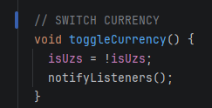
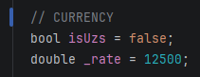

Moreover, there was a challenge during API integration. Specifically, API requests would fail during testing. If not resolved, this would likely lead to getting wrong values for currencies and even to a crash. Therefore, in case API request fails, fallback value for Uzbek sums was added:
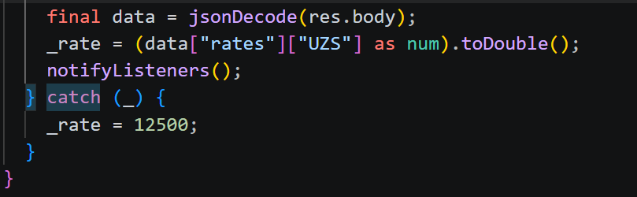

AI Acknowledgement
The aforementioned challenges were integrated using AI. Specifically, AI was used to learn about syntax for integrating Hive service for local storage.
Also, it was suggested by AI to remove the logic for currency from all screens. It was stated that doing so would make it the project cleaner and more readable.
Furthermore, it was also AI that suggested adding a backup plan for API requests, in case they failed. The syntax for implementing this solution was also given AI

Conclusion
In conclusion, this project presents an expense managing app with a clean UI, API integration and proper logic with all the necessary files being in their corresponding folders and therefore having a clean structure.
As stated in the objectives section, this project demonstrates understanding of the materials studied during the course, while also mentioning several challenges faced during development and their resolutions with support of Artificial Intelligence.

List of references

- Pimenta, J. (2025). Flutter Architecture Made it Easy. [online] DEV Community. Available at: https://dev.to/joaopimentag/flutter-architecture-made-it-easy-4b9b [Accessed 23 April 2026].
- Flutter Guys (2023). Clean Architecture in Flutter - All You Need to Know! [online] YouTube. Available at: https://www.youtube.com/watch?v=zon3WgmcqQw [Accessed 28 April 2026].
- yatendra2001 (2023). 🚀 List Of 10 Flutter Libraries and Frameworks to Speed Up Your Development: [online] DEV Community. Available at: https://dev.to/yatendra2001/list-of-10-flutter-libraries-and-frameworks-to-speed-up-your-development-5fe6 [Accessed 3 May 2026].

